LAB EXPERIMENT RECORD

Department | AIML
Course Code / Course Name | DSA0602 / Data Handling and Visualization
Experiment | Data Visualization using Tableau
Name | S.Naveen Kumar
Register Number | 192425176
Date | 10 October 2026
Day | Thursday

SET 17: EMPLOYEE PERFORMANCE ANALYSIS
Aim
To analyze employee performance using R programming by creating a line chart, bar chart, table, and interactive dashboard.

Dataset
The dataset contains Employee ID, Department, Years of Service, and Performance Score.
R Code – Create Dataset employee <- data.frame( Employee_ID = c(1, 2, 3),
Department = c("Sales", "HR", "Marketing"), Years_of_Service = c(5, 3, 7),
Performance_Score = c(85, 92, 78)
)

employee

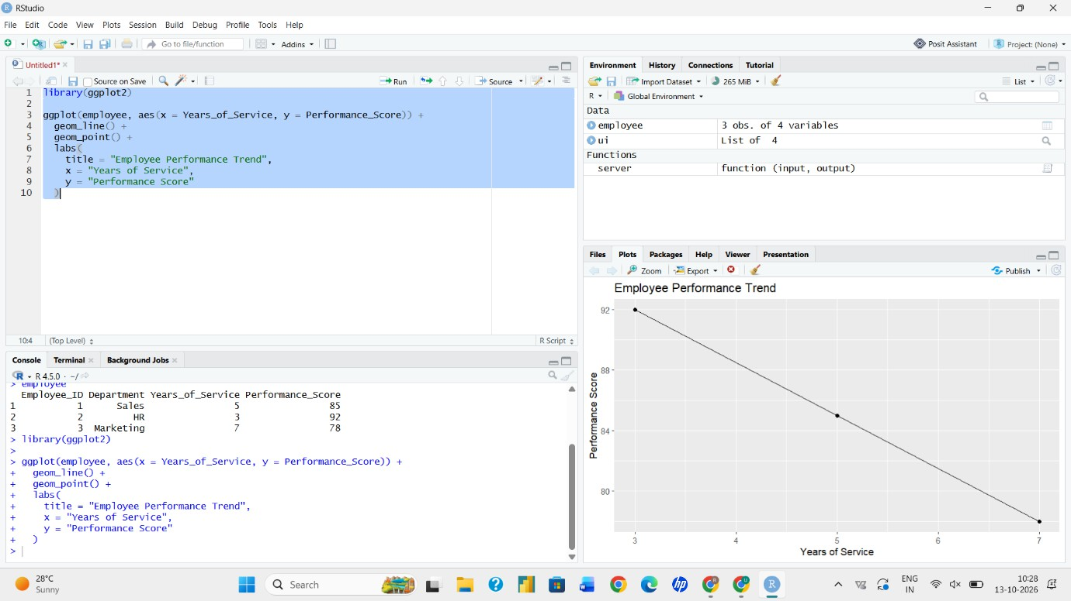

Question 1: Create a Line Chart for Employee Performance R Code
library(ggplot2)

ggplot(employee, aes( x = Years_of_Service,
y = Performance_Score
)) +
geom_line() + geom_point() + labs(
title = "Employee Performance Trend", x = "Years of Service",
y = "Performance Score"
)

Result
The line chart shows employee performance according to their years of service. The highest performance score is 92.

Question 2: Generate a Bar Chart for Departments R Code
ggplot(employee, aes(x = Department)) + geom_bar() +
labs(
title = "Employees by Department", x = "Department",
y = "Number of Employees"
)

Result
The bar chart shows the number of employees in Sales, HR, and Marketing departments.

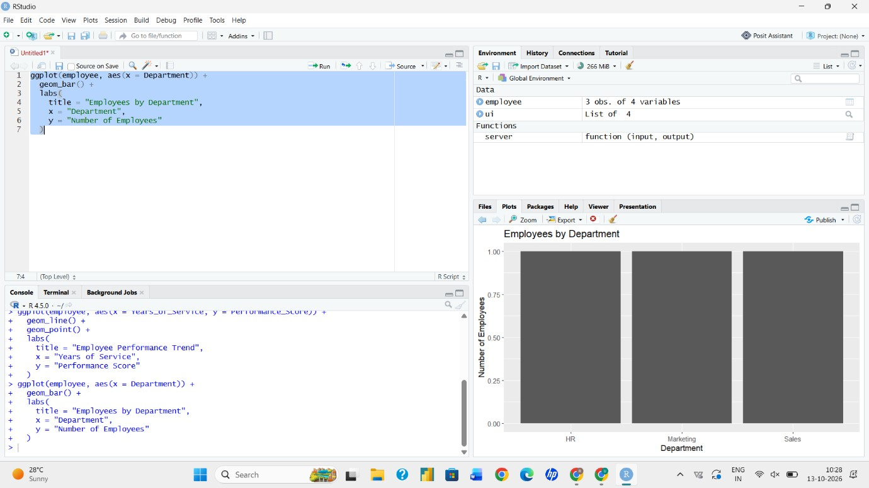

Question 3: Build a Table for Employee Performance R Code
employee

Result
The table displays Employee ID, Department, Years of Service, and Performance Score.

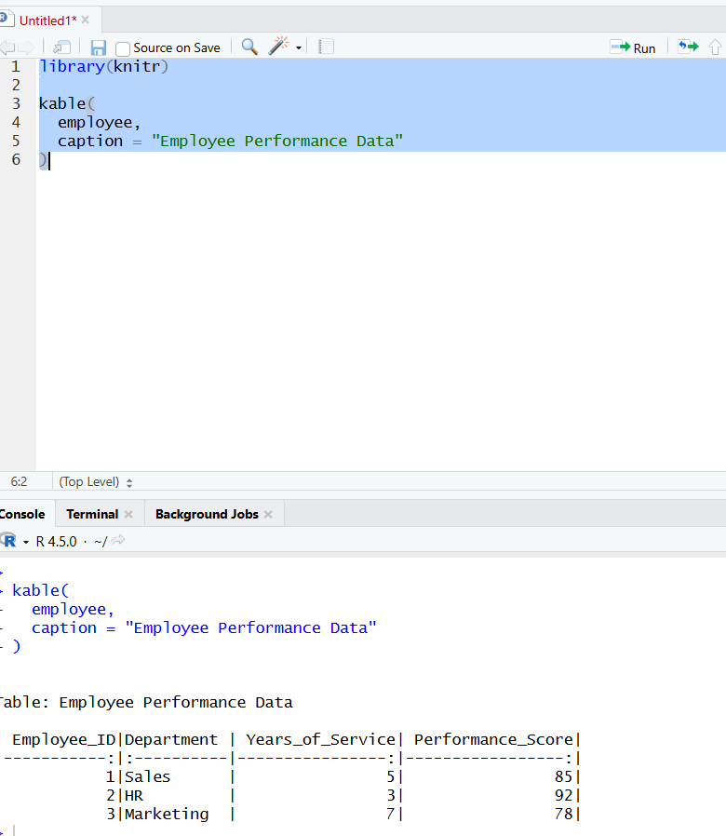

Question 4: Create an Interactive Dashboard R Code
library(shiny) library(ggplot2) library(plotly) library(DT)

ui <- fluidPage(
titlePanel("Employee Performance Dashboard"),

plotlyOutput("performancePlot"), plotlyOutput("departmentPlot"), DTOutput("employeeTable")
)

server <- function(input, output) {

output$performancePlot <- renderPlotly({ p <- ggplot(
employee,
aes(x = Years_of_Service, y = Performance_Score)
) +
geom_line() + geom_point() + labs(
title = "Employee Performance Trend", x = "Years of Service",
y = "Performance Score"
)

ggplotly(p)
})

output$departmentPlot <- renderPlotly({
p <- ggplot(employee, aes(x = Department)) + geom_bar() +

labs(
title = "Employees by Department", x = "Department",
y = "Number of Employees"
)

ggplotly(p)
})

output$employeeTable <- renderDT({ employee
})
}

shinyApp(ui, server)

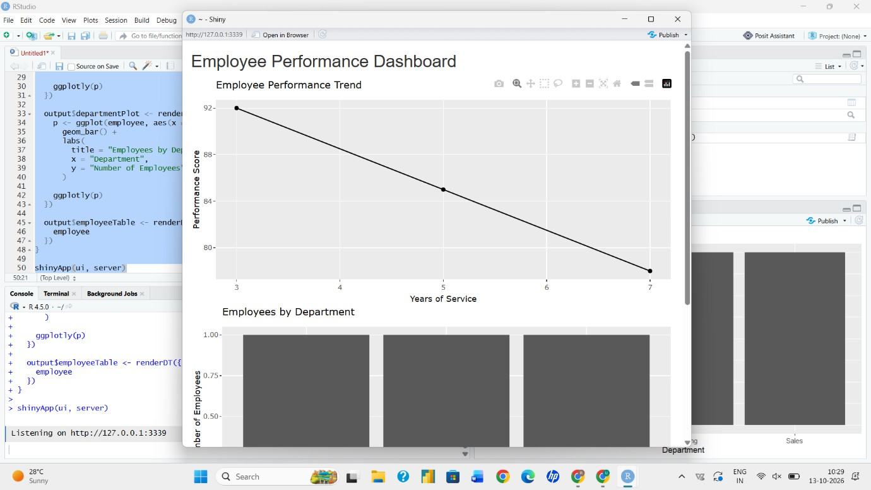

Result
An interactive employee performance dashboard is created containing the line chart, department bar chart, and employee table.

Conclusion
Employee performance data was successfully analyzed using R. Charts, tables, and an interactive dashboard were created to understand employee performance and department information.

